DIAGRAM SEQUENCE PROYEK 2

KELOMPOK 6 :

* Fatimah Nur Suswantoro
* Nisa Fadilah
* Rifki Ega Saputra

Pelanggan side :

1. Menu validasi Register

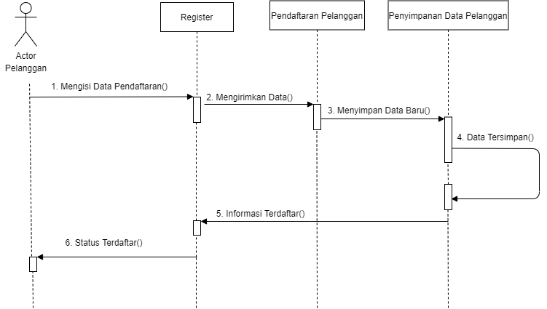

1. Menu Transaksi

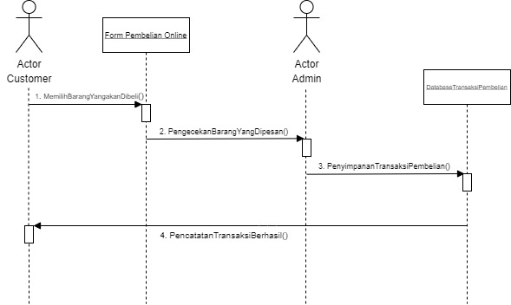

1. Menu Payment

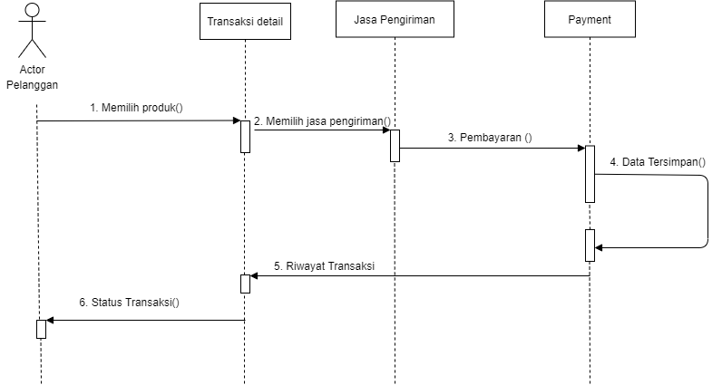

Admin Side :

1. Register Admin

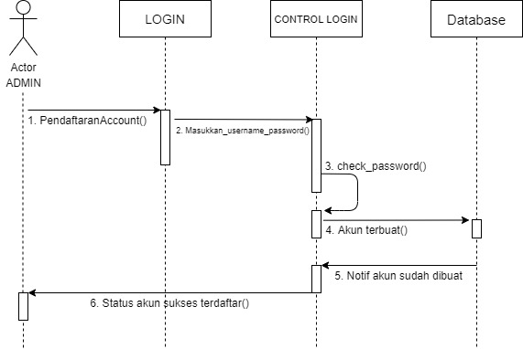

1. Menu CRUD Database ADMIN

Create

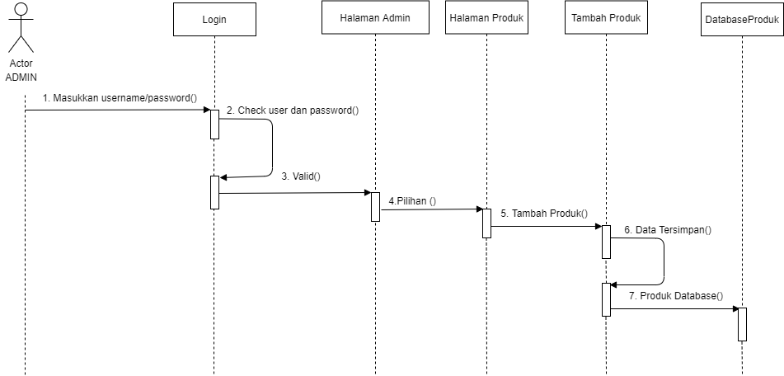

Read

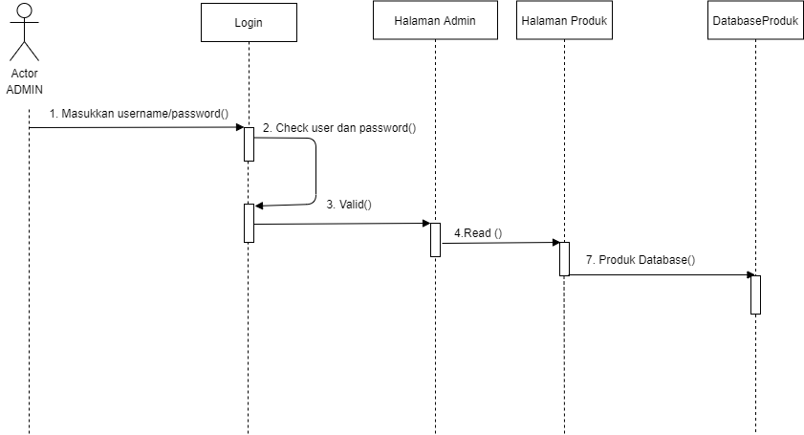

Update

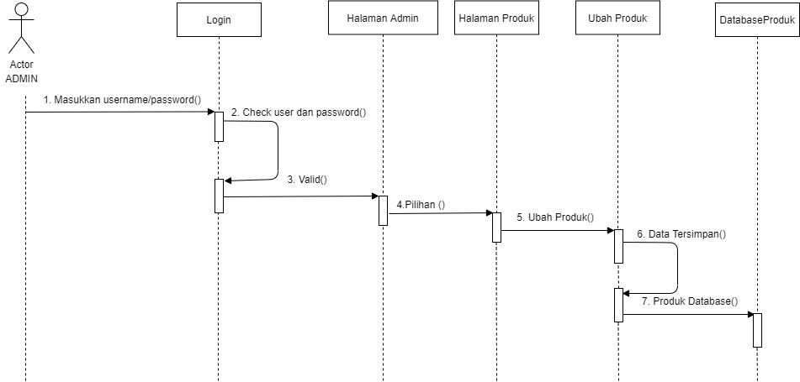

Pesanan Masuk

